**BANA 6760 Data Visualization**

**Assignment-12**

# Topic: Interactive Dashboarding in POWERBI

**University of Colorado Denver**

**Department of Business Analytics**

**Submitted to**

**Professor: Dr. Ellis**

**Submitted By  
Sai Lokesh Siddanathi**

**Customer Engagement Analysis with Power BI**

**Goal**: To Analyse the Customer Engagement and calculate the engagement summary with the helpof Data Visualisation Tool.

**Charts Used:**

* Bar Chart
* Pie Chart
* Column Chart
* Card Visual
* Slicers
* Table Visual

**Analysis detailed on the below components:**

**Amounts Acquired:**

There are different amounts that are generated from the customers. Here is the quick analysis on the amounts collected through different channels. Here is the card visual that displays all the information in a single visual

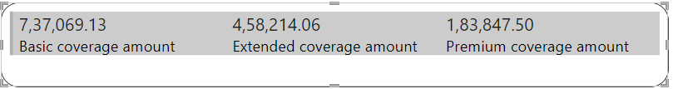

**Customers Through Sales Channel:**

There were different channels for acquiring customers in this sales. Here we have used a pie chart to visualize the number of customers acquired through different channels. Analysis says that ﻿Agent had the highest Count of Customer at 3,477, followed by Branch, Call Center, and Web.﻿﻿ ﻿﻿ ﻿﻿Agent accounted for 38.07% of Count of Customer.﻿﻿ ﻿﻿ ﻿

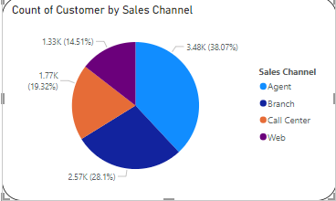

**Total Amounts by Coverage:**

There are different amounts that are covered for the customers. Below is the analysis for the coverage and the customers as it says ﻿At 21,10,474.19, Basic had the highest Sum of Total Claim Amount and was 293.20% higher than Premium, which had the lowest Sum of Total Claim Amount at 5,36,745.56.﻿﻿ ﻿﻿ ﻿﻿Basic had the highest Sum of Total Claim Amount at 21,10,474.19, followed by Extended at 13,17,747.30 and Premium at 5,36,745.56.﻿﻿ ﻿﻿ ﻿﻿Basic accounted for 53.23% of Sum of Total Claim Amount.﻿﻿ ﻿﻿ ﻿﻿Basic had 21,10,474.19 Sum of Total Claim Amount, Extended had 13,17,747.30, and Premium had 5,36,745.56.﻿﻿ ﻿﻿ ﻿

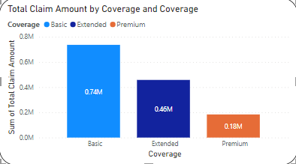

**Total Income by Gender:**

The income is analyzed overall and the Gender is the analysis that is explained for the income generated.﻿﻿﻿Sum of Income for F (177507886) was higher than M (166454623).﻿﻿ ﻿﻿ ﻿﻿F accounted for 51.61% of Sum of Income.﻿﻿ ﻿﻿ ﻿﻿F had 177507886 Sum of Income and M had 166454623.﻿﻿ ﻿﻿ ﻿ F stands for Female and M stands for Male.

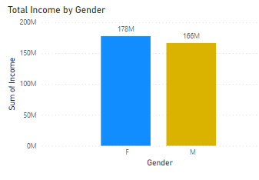

**Total Claims by State:**

This Analysis states the Number of claims made for every state. Here we have used a Column chart to visualize the amounts that are claimed. It is understood that ﻿At 13,79,130.69, California had the highest Sum of Total Claim Amount and was 296.07% higher than Washington, which had the lowest Sum of Total Claim Amount at 3,48,202.19.﻿﻿ ﻿﻿﻿﻿ ﻿﻿California accounted for 34.78% of Sum of Total Claim Amount.﻿﻿ ﻿﻿ ﻿﻿Across all 5 State, Sum of Total Claim Amount ranged from 3,48,202.19 to 13,79,130.69.﻿﻿ ﻿﻿ ﻿

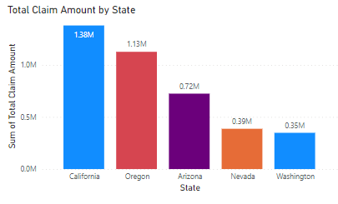

**Total Income by Marital Status:**

Income by marital status plays an important role in understanding the income statistics. It is understood that ﻿At 232128823, Married had the highest Sum of Income and was 316.67% higher than Divorced, which had the lowest Sum of Income at 55710897.﻿﻿ ﻿﻿ ﻿﻿Married had the highest Sum of Income at 232128823, followed by Single at 56122789 and Divorced at 55710897.﻿﻿ ﻿﻿ ﻿﻿Married accounted for 67.49% of Sum of Income.﻿﻿ ﻿﻿ ﻿﻿Married had 232128823 Sum of Income, Single had 56122789, and Divorced had 55710897.﻿﻿ ﻿﻿ ﻿

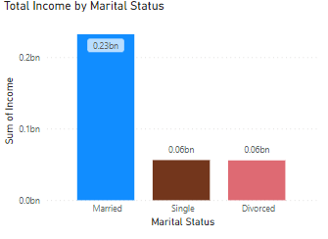

**Coverage By Policy Type:**

﻿At 6,788, Personal Auto had the highest Count of Coverage and was 1,695.77% higher than Special Auto, which had the lowest Count of Coverage at 378.﻿﻿ ﻿﻿ ﻿﻿Personal Auto had the highest Count of Coverage at 6,788, followed by Corporate Auto at 1,968 and Special Auto at 378.﻿﻿ ﻿﻿ ﻿﻿Personal Auto accounted for 74.32% of Count of Coverage.﻿﻿ ﻿﻿ ﻿﻿Corporate Auto had 1,968 Count of Coverage, Personal Auto had 6,788, and Special Auto had 378.﻿﻿ ﻿﻿ ﻿

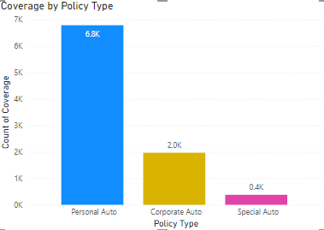

**Over all Analysis:**

﻿Basic Coverage had the highest total Sum of Total Claim Amount at 21,10,474.19, followed by Extended at 13,17,747.30 and Premium at 5,36,745.56.﻿﻿ ﻿﻿ ﻿﻿California in Coverage made up 18.59% of Sum of Total Claim Amount.﻿﻿ ﻿﻿ ﻿﻿Basic had the highest average Sum of Total Claim Amount at 4,22,094.84, followed by Extended at 2,63,549.46 and Premium at 1,07,349.11.﻿﻿ ﻿﻿ ﻿﻿[]﻿﻿ ﻿﻿ ﻿

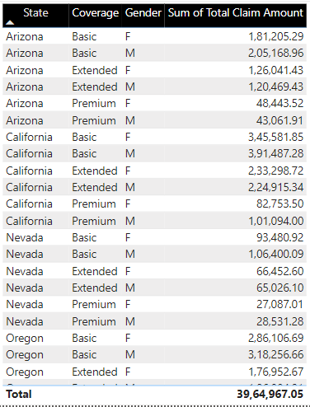

**Conclusion:**

From the Regression Analysis, we can use it for finding the significance of Variables and only Income, Number. Of. Policies, and Total. Claim. Amount had significant correlations with the variable Engaged, according to the results of this regression study. Income and Total. Claim. Amount are positively related to Engaged (coefficients are positive). That means that the higher our clients' income and total claim amount, the more likely they are to interact.